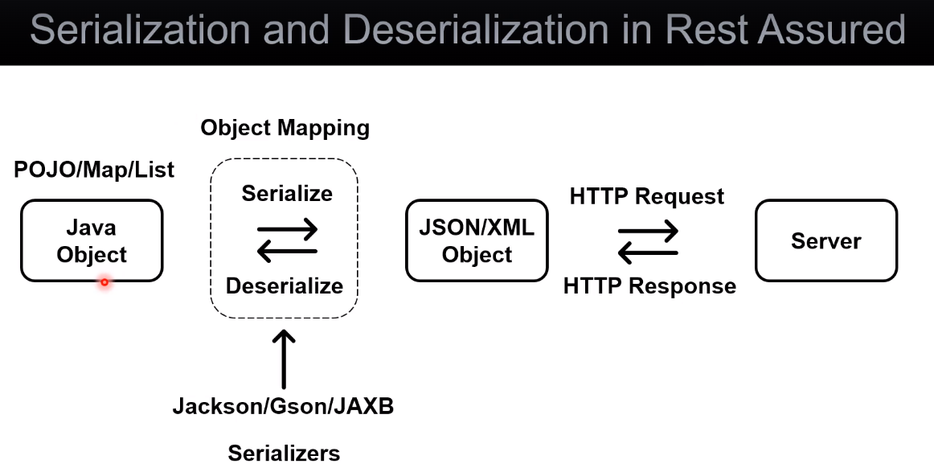

Java object, it can be POJO, Map, List, it is converted to JSON or XML object and this process is called - **serialization**,

and it is done by different libraries (Jakson, Gson for JSON, JAXB-for xml object) these libraries are called as - serializers. Once the Java object is serialized into JSON or XML object then it is sent as a request payload as part of an HTTP request that goes to the server. The server then process the request and sends back HTTP response.

The HTTP response might have a response body, which can be JSON or XML object. Then this JSON or XML object converted back to Java object and this process is called - de **serialization**.

The process of serialization and de serialization is called - **object mapping**.

Why we are doing it while working with Rest Assured ?

Because dealing directly with JSON or XML object might be challenging. The JSON and XML object kind of technical representation of the object, while the Java object (especially POJO) representation will be simple. And since we are using the Java programming language, representing an object as a Java object brings a lot of benefits. We can easily create objects, fetch objects, maintain them, and re-use them and in case if it is POJO it is readable as well.

The important note is that serialization and de serialization is done internally by Rest Assured and it is uses one of these libraries under the hood.